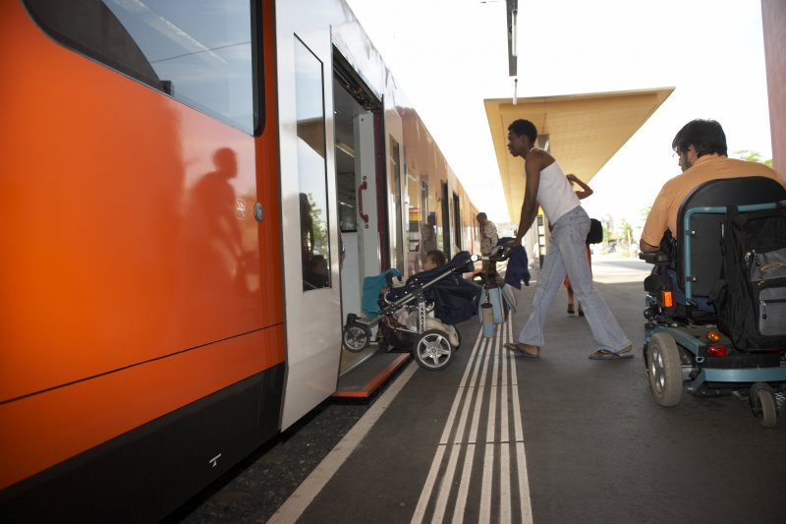

User Research Report and Personas

Mobility for Physical Disability | Yiping Li, Ginsu Eddy, Phuong Vu, Anna Fair, Chris Yin

INFO 200 Problem Statement | BB | JoJo Saunders

**Table of Contents**

**Problem Brief**  **2**

**Existing Solutions** **2**

Existing Solution 1: Wheelmap 2

Existing Solution 2: Dial-A-Ride services 3

Existing Solution 3: Google Maps 4

**Stakeholder Groups** **7**

Stakeholder 1: People in wheelchairs 7

Stakeholder 2: Baby Transport 7

Stakeholder 3: Elderly 7

**User Research** **7**

Surveys 9

Interviews 10

Stakeholder Interview 10

User Interview 1 10

User Interview 2 10

**User Personas** **11**

**Conclusion (~ 50 to 75 words)** **13**

**Bibliography** **13**

**Appendix** **13**

Interview Notes 13

Survey Results 13

# Problem Brief

Whether it’s due an injury or something at birth, there are many people who have experienced and are currently experiencing some sort of physical disability which will have made it difficult to get from point A to point B. We are choosing to help this space because while for many people this disability might be temporary, for others it is not and working in this space will encourage and bring awareness to people to the needs of physically disabled.

# Existing Solutions

## Existing Solution 1: Wheelmap

[Wheelmap](https://wheelmap.org/search) provides a map designed for people with physical disabilities, increasing the chance they go out. It tells whether something is wheelchair accessible for example like buildings and public transportation pick up sites . It allows users to add images and to mark whether it is wheelchair accessible for any places. On the map, they use green and red icons to identify its accessibility, which very “accessible” in itself. However, not all of the buildings have been added to the map by users yet. Moreover, it does not show whether a road is accessible and just a small portion of bathrooms are marked on the map. Unlike Google maps, it does not find the shortest or eve most accessible path in terms of its navigation feature. Although it has more features and labels than normal maps, it still lack coverage and support. In the last seven months, only five users have rated the app on the Apple App Store, so not many people have used it and is not very known. Not only that, there is little to no media coverage on this app (Morris, 2018).

* 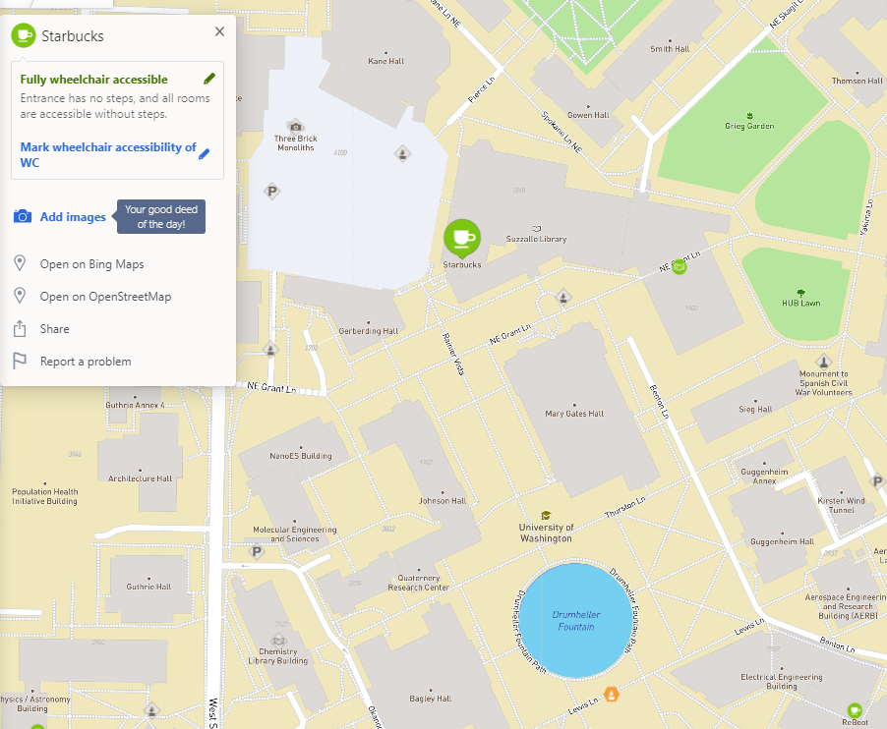

## Existing Solution 2: Dial-A-Ride services

Dial a Ride Transit is a type of fixed route service with King County Metro that uses smaller ride sharing vehicles that can pick people up at specific destinations and take them to desired destinations from phoned or online requests. Those vehicles are fitted with wheel-chair lifts and can go where other public transportation can’t go. Here’s a [link](https://kingcounty.gov/depts/transportation/metro/travel-options/bus/dart-service.aspx) to its website.

This is great solution because this allows people who are physically handicapped to be able to be picked up wherever they are, however reservations for pick up must be made at least two hours before their requested pick up time. Where all of the requested pick up times must be during certain hours on certain days, not 24/7 (DART service, 2019).

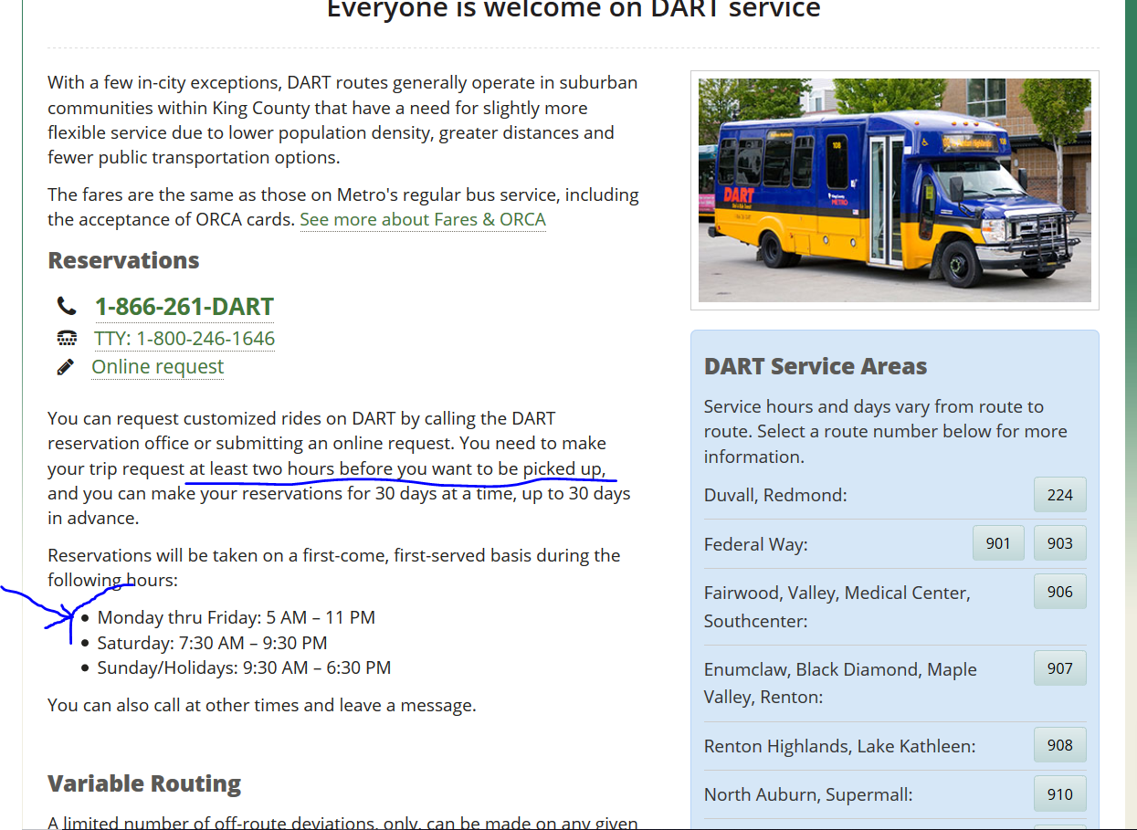Issues in blue

King County Metro is not the only entity that uses this service model.

[University of Washington](https://depts.washington.edu/uwdrs/current-students/accommodations/dial-a-ride/) uses this type of same type of service for its disabled students. Benefits and issues are similar however a request must be made 1 hour faster, big difference but having to wait one hour is still a long time compared to how fast Uber or Lyft work (Dial-A-Ride).

Overall this solution is very good to an extent and can be greatly improved upon.

## Existing Solution 3: Google Maps

Google Maps is arguably the most popular service in the world when it comes to getting directions to anywhere in the world. Google has and utilizes a vast pool of data which helps analyzes patterns in creating driving, walking, and transit navigation routes making Google Maps really effective when traveling. Last year, [Google Maps](https://www.google.com/maps) introduced “wheelchair accessibility” in their transit navigation option which helps people who are physically disabled navigate around places that are not wheelchair friendly.

Google Maps does a really good job at providing users with real time navigation and showing maps and routes all over the world. With their wheelchair accessibility feature, they continue this trend and will detour users to avoid routes that require users to go through things like stairs. While Google Maps does a great job at routing users from point a to point b outside, it does not do such a good job navigating when users are in buildings such as a train station or a mall, said by [TechTimes](https://www.techtimes.com/articles/223113/20180317/google-maps-is-now-wheelchair-friendly-here-s-how-to-find-wheelchair-accessible-routes.htm) (Velasco, 2018).

In addition to not being able really navigate and detour to avoid handicap obstacles inside facilities that well, the wheelchair accessibility options are quite difficult to find. (the red annotations in the picture below highlights the steps needed to select the wheelchair accessible option.) Overall it’s a great step in the right direction, but could use some improvements in a lot of areas.

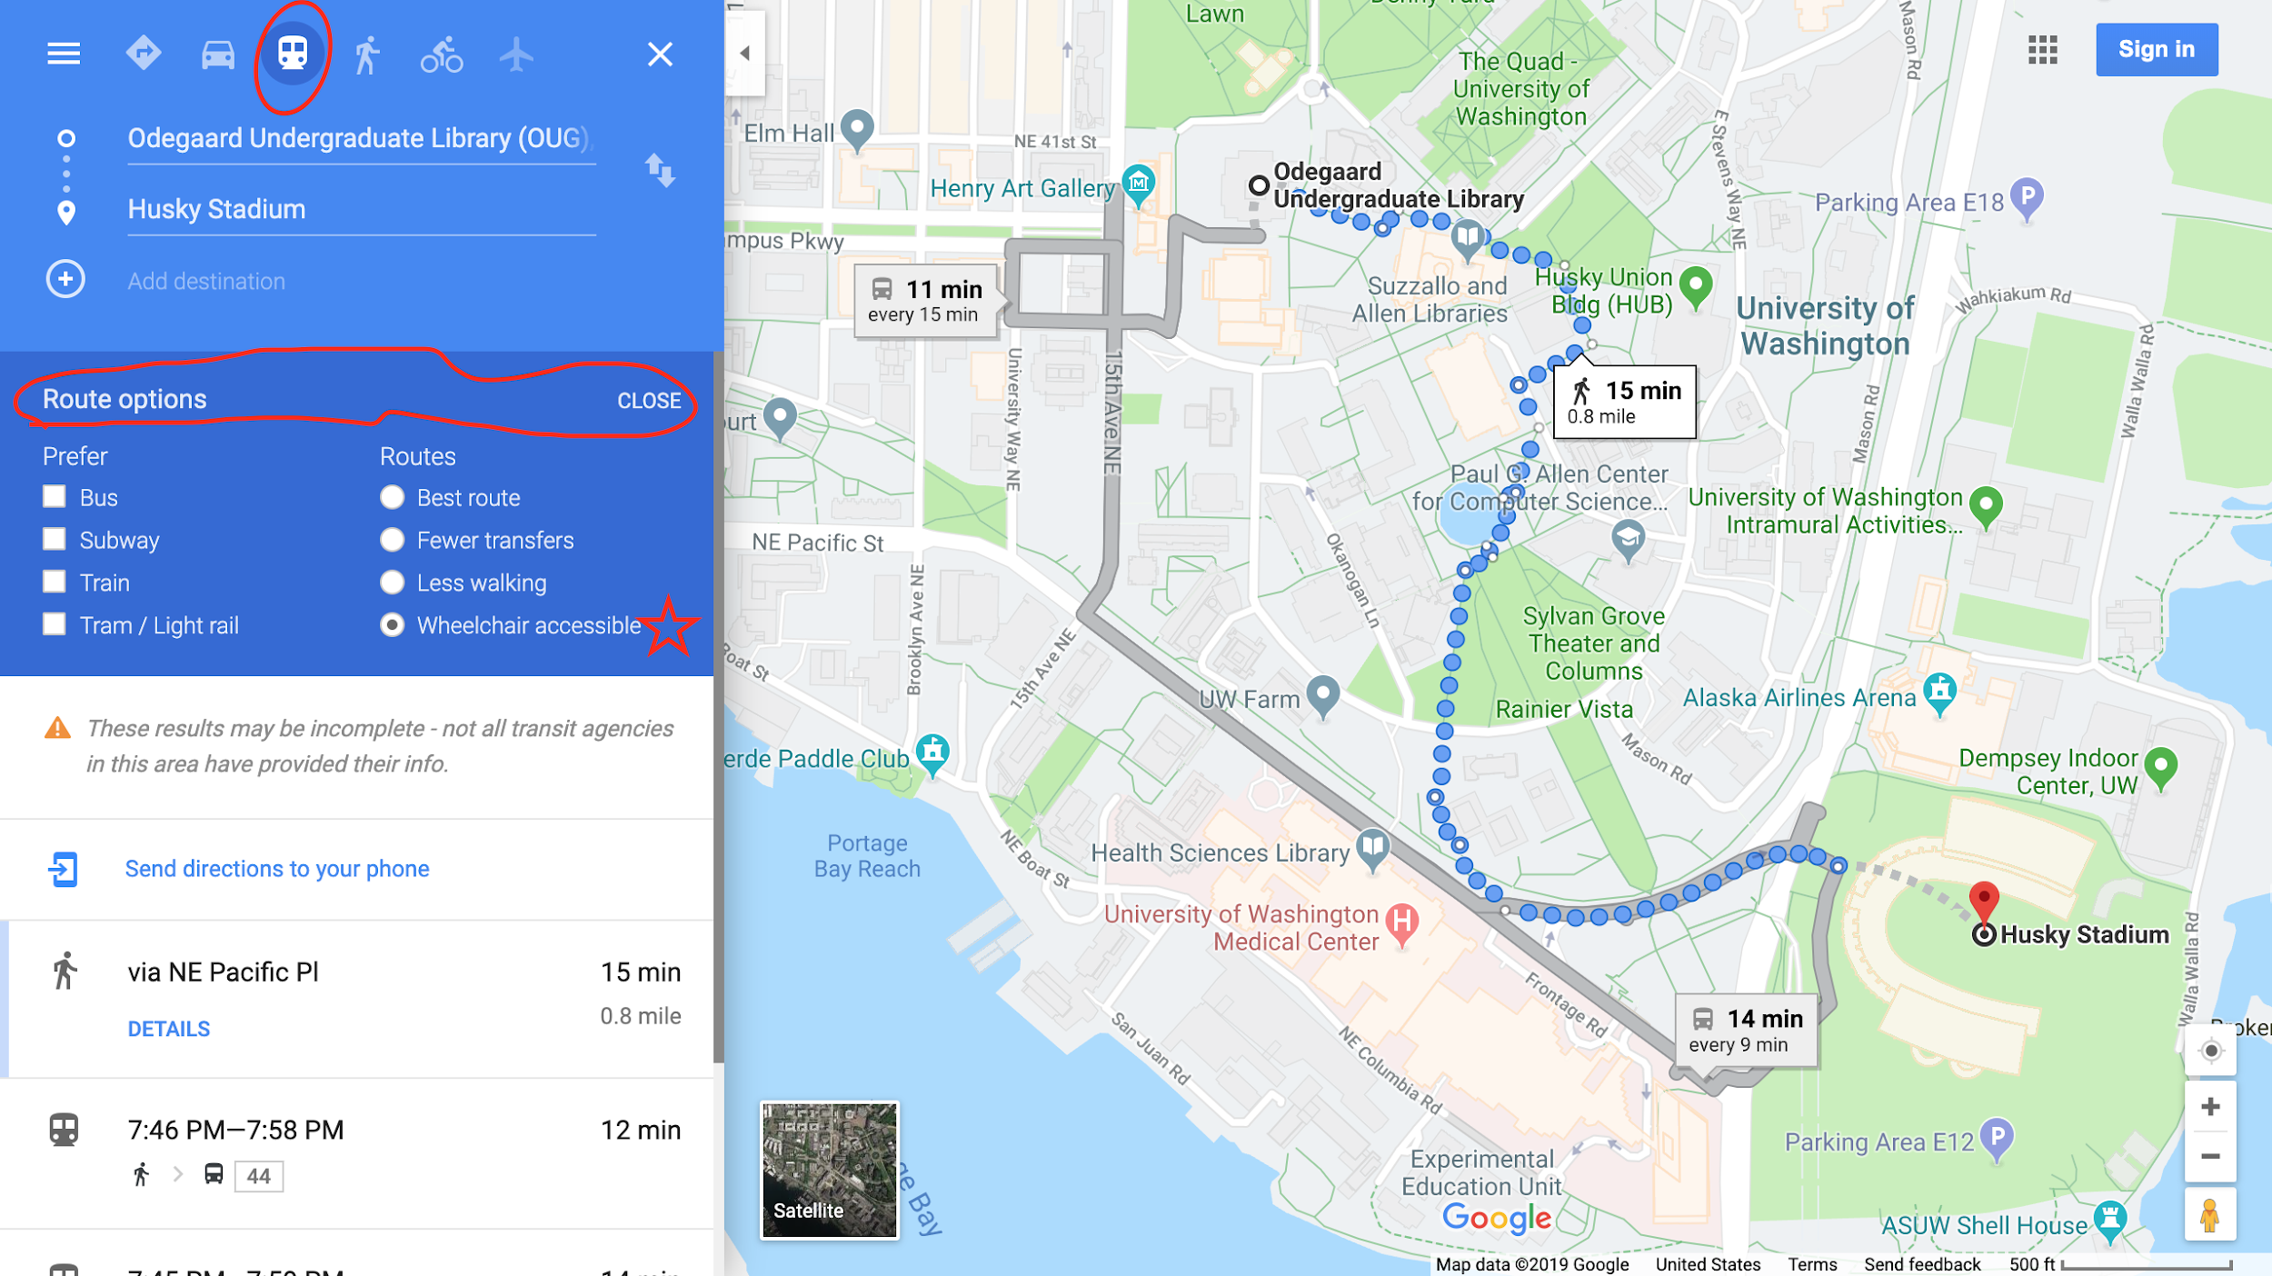

## Table: Comparing the Three Existing Solutions

|  |  |  |  |
| --- | --- | --- | --- |
|  | **Existing Solution 1** | **Existing Solution 2** | **Existing Solution 3** |
| **What does the existing solution do well?** | Listing the accessibility of a building or a facility on the map | Picks people who are handicapped at any destination and takes them to their desired destination.  Affordable. | Gives real time directions and navigation routes and detours physically disabled users around things considered obstacles outside. |
| **Where does the existing solution fall short?** | Cannot indicate the path between two places; No accessibility information for the routes. | The time it takes to make a request takes too long and hours are limited. | The solution is a bit difficult to find and is only available in the ‘transit option’. In addition, there is no way to navigate indoors. |
| **How are they similar?** | They all provide some information about accessibility for disabled and trying to eliminate their transportation difficulties. | They all try to help disabled people travel from one place to another. | They all give users information about obstacles on the route or at the destination. |

# 

# Stakeholder Groups

## Stakeholder 1: Physically disabled

Physically disabled make up majority of our direct stakeholders. In their perspective and condition, traveling from one point to another could be either a simple task or a significant challenge due to the non-accessible environment. For example, it is impossible for physically disabled in wheelchairs to predict and travel over uneven grounds and rough terrain by themselves. In addition, people in wheelchairs are unable to foresee whether ramps are available in places with stairs on their route. Therefore, it would take them extra effort and time to figure out the other route as they encounter these difficulties on the way (Karman Healthcare). The physically disabled will be one of our major stakeholders.

## Stakeholder 2: Parents with babies and toddlers

Parents who have babies or toddlers are also affected by mobility difficulties as well. Since babies and toddlers do not have the ability to walk alone, their guardians must carry them or have them in a stroller. Hence, their mobility is limited in some degree. One of the inconveniences comes from when they use strollers to get their baby around. For example, in Philadelphia, a mom recently died trying to carry a stroller up the stairs in the train station (Reinde, 2019). If parents can’t safely take their babies or toddlers to public spaces, this is a major accessibility problem and special accommodations will be needed. With these special accommodations that are required for parents with babies and toddlers, this indicates that parents with their babies or/and infants in strollers will be most likely affected by our solution.

## Stakeholder 3: Elderly

As people age, their physical ability becomes more and more limited. So getting from point A to point B is much of a challenge. According to the Census Bureau, mobility is the most common disability among the elderly. In the period of 2008 - 2012, ⅔ of those who had a disability over the age of 65 said they had difficulty walking or climbing. In other words around 10 million Americans elderly. With disabilities that come with aging, our solution will always be relevant.

Since our solution will be catered to those who find it difficult in terms of mobility, the elderly will be a major stakeholder due to the sheer number of how many disabled elderly need assistance to get to places (US Census Bureau, 2014).

# User Research

## Surveys

The purpose of the survey was to get personal information about physical disability from all walks of life. This can give us a very broad picture of what disability looks like to certain people.

This method of gathering information was appropriate because it allowed us to get a lot of significant information about disability without having to interview each person and getting anonymous input so our data wouldn’t be biased.

The demographics that were collected was location, income, and race/ethnicity. The reason why these pieces of information was collected was to compare and contrast demographic data with those with physical disabilities and those that don’t. Demographics are important because it can show a lot about a person in society and gives guidance in finding correlations.

One of our key questions was the device that was used to aid the person’s disability and whether or not public transportation/buildings were accessible.

We had 30 respondents for our survey. Of our 30, 2 were not from the U.S., 2 were from a US state other than Washington and the remaining 26 were from various cities in the western half of Washington. From our survey, we were able to find that an astonishing 40% had at some point point been physically disabled to a certain extent. Of those that were disabled, 30% needed assistance getting from one place to another. We also gained insight that not everyone is able to access public buildings and transportation or even feels comfortable being around others. Ultimately, we learned that being physically disabled to some extent can extend to other stakeholders and aspects of daily life.

Interviews

### Stakeholder Interview

We tried to find the transportation difficulty for infant carriers by interviewing a mom that Mark knows who currently has a 6 month old baby. The interviewee fits in our target stakeholder, and we are able to adjust and refine our solutions from her experiences. We have asked questions on the transportation inconveniences while carrying her baby and using a stroller. Also, questions of whether she encountered any troubles with finding the bathrooms with changing tables and lactation rooms in public spaces. Those answers to those questions that were asked will help us to examine our user research and to determine whether this population fits our direction.

Her responses show that the issue is not as serious as we expected. The changing rooms and lactation rooms are available for most of malls and are shown on the mall directory maps clearly. But one of the problems she mentioned is that places like parks do not have those special accommodations. Moreover, she didn’t find anything transportation inconveniences while carrying the baby around, which is because she and her partner usually don’t take public transportation. Now this is only one parent’s experience and this single sample cannot represent the overall population but it covers ground. Our interviewee was from a higher income bracket, so this doesn’t represent the potential problems single parent or low income families with infants face. In the future, we will ask people in those specific demographics for feedback.

### User Interview 1: Tam Phi

For the first interview, we interviewed Tam Phi, a friend of Phuong, who broke her ankle three times during basketball practices. The repeated injuries on the same ankle caused her to be on a wheelchair for two years and even now, she still sometimes feels in her ankle pain when running or moving. The purpose of this interview was to get a complete understanding of how difficult it is for people who are on wheelchairs to move from one place to another when there are not obvious points of access for disabled people. This research method was appropriate because through this one on one interview with Tam, we are able to empathize with her emotions and personal experience that we would normally not get from other research methods. One of the most important questions that Phuong asked her during the interview was “How did you travel from one place to another?”. This question was important because it was a starting question that was used to ask further questions and elaborations about her experiences, the difficulties she had moving around.

From this interview, we realized that despite the significant development in the access for disabled people, people on wheelchair still have to face several challenges to complete their everyday tasks. In particular, Tam mentioned that when she was in high school, she used the school bus to get to school. However, unlike some of the other public buses with accessibility ramps for wheelchair users, the school buses did not have one requiring her to get help from her family and friends each time she got on and off the bus. Moreover, she also tried to use the wheelchair accessible feature on Google Map to navigate and find her way around. However, this feature is not available in some areas that she went to. However, she was able to use this feature during her spring break in Boston and it helped a lot. However, when she went back to Pennsylvania for her school, she could not use the wheelchair accessible feature anymore because it was not available in her area. From Tam’s experience, we can see that there are still many limitations people with disabilities face because of the inaccessible physical environment.

### User Interview 2: Jonny Smith

For the second interview, we interviewed Jonny Smith, a neighbor of Ginsu, who is currently 88 years old and has trouble walking around, especially up and down the stairs due to his old age and multiple knee surgeries a couple of years ago. The purpose of this interview was to be able to empathize what it is like to go from being able to freely walk anywhere to needing to rely on other people or things to move simply due to the natural process of aging, something everyone will go through. I felt that this method of interviewing was more appropriate than surveying because as a team we really needed to understand the daily life and experience of someone who used to have everything to now nothing; and a survey would not really be able to empathize. The key questions that Ginsu asked were things like, “what is it like getting from point a to point b by yourself right now” and “how did you adapt to your new situation”, in addition to many more. All of these questions helped us to paint a picture and empathize with the experience of having to rely on so many things in order to simply go somewhere.

Through this interview, I was able to gain the understanding of how difficult it is physically and mentally for people who are elderly to move around without any assistance from other parties. For example, I learned that Jonny found that many of the accessible routes were extremely hard to find and he had to rely on asking random strangers who many aren’t inclined to help him look for signs showing a possible accessible route. In addition, he complained that when he and his friends were able to find the accessible routes they would always be put in the most inconvenient places. Jonny volunteers in a church and he says that the elevator is located at the very back of the building, so he needs to go all the way down and back just to go up a level. He said that sometimes it felt like it might just be faster to just put his body in more pain to climb up those stairs instead of going all the way around to reach the elevator. Jonny also said that because elevators aren’t very common everywhere sometimes he would just have to give up on what he was doing and because of this does not like going out that much. He says that he is surprised that a solution is not really present especially since many people will possibly experience this at some point naturally due to old age. After Ginsu interviewed Jonny, he did some research on how many people need some sort of mobility device, and at what age and he was surprised to see that about 30% of males and 40% of females need mobility devices by the age of 85, (results posted below).

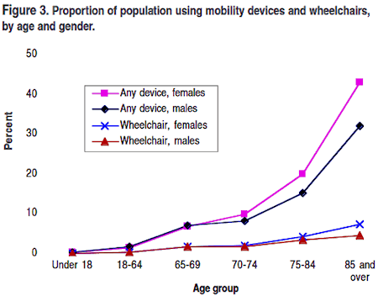

(University of California - Disability Statistics Center, 2018)

# User Personas

# Conclusion

From all of our research we realized that mobility disability is not only a problem people in wheelchairs have but affect many more stakeholders, such as the elderly, or people with a baby stroller. We were also able to gather a common theme among all of our interviews and surveys: there is currently not a solution to help people with a physical disability navigate indoor areas. As we prepare our solution, we will aim our focus at this problem.

# Bibliography

US Census Bureau. (2014, December 08). Mobility is Most Common Disability Among Older Americans. Retrieved from https://www.census.gov/newsroom/press-releases/2014/cb14-218.html

University of California - Disability Statistics Center. (2018, September 28). Mobility Device Statistics: United States. Retrieved from <https://www.disabled-world.com/disability/statistics/mobility-stats.php>

Daily Problems and Challenges of Using a Wheelchair. (n.d.). Retrieved from <https://www.karmanhealthcare.com/daily-problems-and-challenges-of-using-a-wheelchair/>

DART service. (n.d.). Retrieved May 6, 2019, from <https://kingcounty.gov/depts/transportation/metro/travel-options/bus/dart-service.aspx>

Dial-A-Ride. (2016, October 18). Retrieved May 6, 2019, from <https://depts.washington.edu/uwdrs/current-students/accommodations/dial-a-ride/>

Morris, J. (2019, January 25). 15 Smartphone Apps for Travelers with Disabilities. Retrieved May 6, 2019, from <https://wheelchairtravel.org/15-smartphone-apps-accessible-travel-disability/>

New Mom Guide: Going Out with Baby. (2014, March 19). Retrieved May 6, 2019, from <https://www.parenting.com/article/new-mom-guide>

Other, A., Glen, C., Livvie, & Rhee, J. (2015, November 18). Gov't panel discusses baby stroller use on public transportation. Retrieved May 6, 2019, from <https://japantoday.com/category/national/govt-panel-discusses-baby-stroller-use-on-public-transportation>

Rinde, M. (2019, February 12). Strollers pose safety problems for Philly families riding SEPTA. Retrieved from https://whyy.org/articles/moms-fatal-fall-carrying-a-stroller-on-nyc-subway-triggers-scary-memories-for-philly-families/

Times, C. V. (2018, March 17). Google Maps Is Now Wheelchair-Friendly: Here's How To Find Wheelchair Accessible Routes. Retrieved May 6, 2019, from https://www.techtimes.com/articles/223113/20180317/google-maps-is-now-wheelchair-friendly-here-s-how-to-find-wheelchair-accessible-routes.htm

# Appendix

## Interview Notes:

*Interview Notes from Tam Phi interview (Interview 1):*

Phuong: How did you end up on your wheelchair/ crutches?

Tam: I broke the same ankle three times during basketball practices. Thus, it takes longer for my ankle to recover and even now sometimes I do have difficulties running with my ankle. For the first time I broke my ankle, I used crutches. But after that, I used wheelchair for the next two years.

Phuong: How did you travel from one place to another?

Tam: For the first time breaking my ankle, I used crutches. After that, I started using wheelchair for transportation. But I still mostly relied on friends for helping to move to places.

Phuong: Did you take any public transportation?

Tam: For transportation from home to school during my high school, I rode school bus. I think it does count as public transportation, right? But I also ride buses sometimes when I have no other options.

Phuong: Is it convenient to use that public transportation? If not, specify why.

Tam: It is actually pretty convenient to use buses. However, my high school bus was horrible. Unlike some of the public buses, my school bus does not even have ramps. As a result, my mom, brother, and friends had to help me to get onto and down the bus. I wish they made ramp or something like that to help students like me out.

* Note: Tam seems a little pissed when she talked about her school bus.

Phuong: Did you use any map applications? If yes, which one?

Tam: Yea, I used Google Map Wheelchair accessible feature before. But I don’t know whether it still exist or not. I haven’t used it in a while.

Phuong: Did you have any difficulties using the applications? If yes, what is it?

Tam: The wheelchair accessible feature on Google Map actually was nice. I found out and used it during my spring break in Boston. But then as I went back to school, I realized the feature is not available in my area. Then, I heard my friends in New York said they still had it. Thus, I think the feature is just accessible in certain regions. That actually upsets me a lot back then.

Phuong: On the scale from 1 to 10 with 10 is the most useful, how I do you rate the current map applications?

Tam: I would give 6 out of 10 because during my break, it sometimes showed me routes with roads that were under construction. I had to find another way to avoid the road myself. And it is not even available in my city so that is a minus too.

Phuong: What can be improved from the application to give you more convenient experience traveling around with your leg difficulties?

Tam: I wish the map application can be more practical with accurate and updated information about roads, buildings and public place. Also, I hope Google can get its wheelchair accessible feature more viral and accessible in different places because there are people on wheelchair everywhere you know.

*Interview Notes from Jonny Smith Interview (Interview 2):*

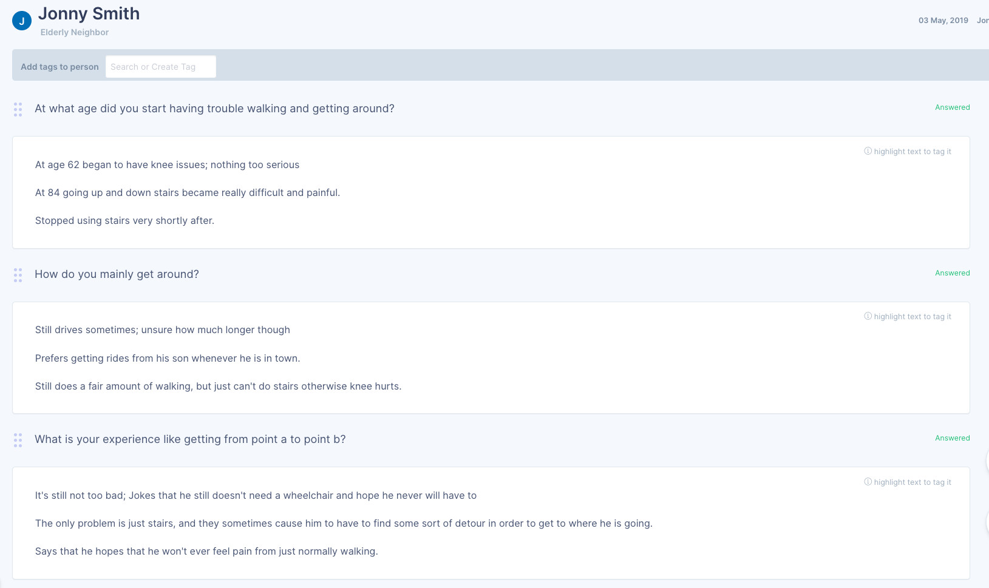

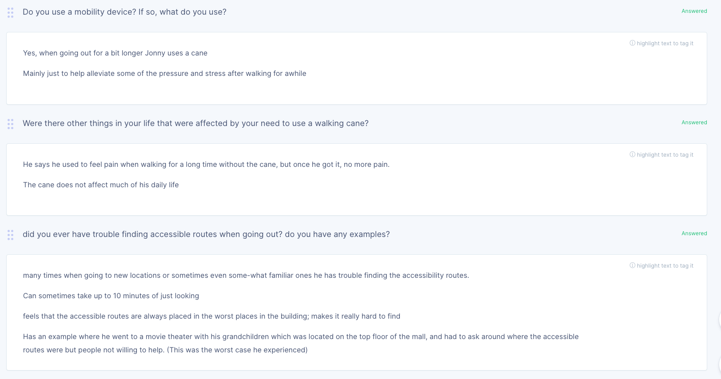

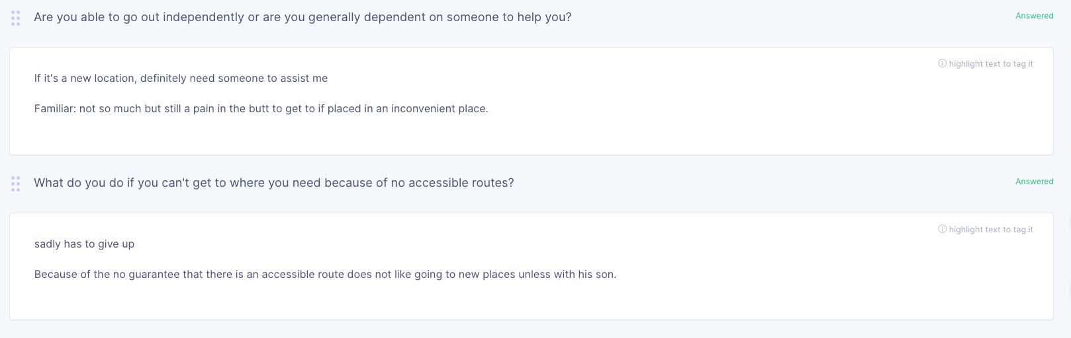

Stakeholder Interview:

Q: Are you less likely to go out after your baby was born?

A: Yes, it was busy, so we don’t have time to do it.

Q: Will you bring your baby while shopping?

A: Yes

Q: Do you use stroller when you go outside with your baby?

A: Yes

Q: Do you experience any difficulties with the stroller? Like having troubles with moving it upstairs or having troubles with finding the elevators.

A: No, not really.

Q: Do you have any trouble with finding the bathrooms with changing tables and lactation room?

A: No. Most of stores and malls have those facilities, which are marked on their map clearly. But places like park don’t have them, so we didn’t even try.

Q: Do you have feel any inconveniences while you were carrying you baby around.

A: No, not at all. I drive my car for the most of the time. Usually, most places I went are pretty empty since it is on work days.

## Survey Results

From our survey responses, some of the demographics we learned were that 3.4% of the respondents were aged 18 or under, 82.7% of our respondents were aged 19-28, and 13.8% were aged 29 or older. The results also showed that approximately 86% of our respondents reside western Washington near the Seattle area while 6.6% live in a different state than Washington while 6.6% of our respondents do not reside in the United States. Surprisingly exactly 50% of our respondents identified as female while the other 50% identified as male. 73% identified as Asian, 20% identified as Caucasian and the last 7% identified as mixed race. A last demographic that we were able to learn was that approximately ⅓ of our respondents (33.3%) did not have a job or work, 20% make 10K or less a year, 10% make $11-$20K a year, 16.7% make anywhere from $30K-$50K annually, 6.7% make $60K-$100K a year, while the final 13.3% makes more than $100K annually. When asked if they had ever been physically disabled to some extent 40% of our respondents answered yes while the other 60% answered no. Of those that responded 30% needed assistance to get from place to place. Of those 30% that needed assistance, 66.6% of them used crutches while 22.2% used a wheelchair and the last 11.1% used a cane. When asked if public buildings and transportation were accessible to them, 86.7% of our respondents got back to us. Of those 86.7%, 84.6% said that public buildings were accessible to them while 15.4% said that public buildings were only sometimes accessible to them. Following that 73.1% said that public transportation was accessible for them. However, 19.2% said it depended on the type of transportation and an additional 7.7% said that public transportation was not accessible for them. When asked if they felt comfortable around people, we had one particular respondent admit that they were only sometimes comfortable being around others and also noted other challenges such as discomfort from having to use crutches.